1. Use this function to show your images in your code. Use .ipynb extension . 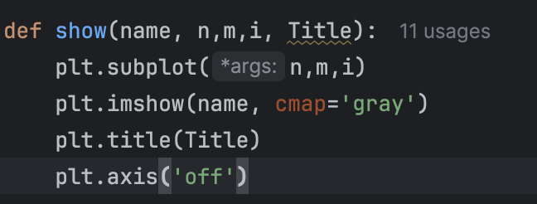
2. Take a image from your PC using cv2.VideoCapture(0). Sometimes you need to change your camera option to cv2.VideoCapture(1), etc . Write functions (def) for the following and print it in a 2*4 grid (n=2 , m=4).
   1. Grey scaling
   2. Thresholding images
      1. Containing only 2 colors (black and white), set a threshold above which pixels are black.
      2. Containing 16 grey colors ( you have to divide the range of 0-255 into 8 regions).

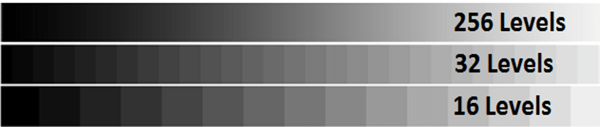

* 1. Sobel filter and Canny edge detector. Compare which one is better !, search on chatgpt the difference. (print both)
  2. Filter/remove noise from the image using a Gaussian kernel , create the kernel through a matrix. (Just saying to apply a gaussian filter )
  3. Now sharpen the blurred image in d using another kernel, see more on <https://en.wikipedia.org/wiki/Kernel_(image_processing)>
  4. Convert RGB to BGR color channel . FInd out what is default color theme in your IDE.

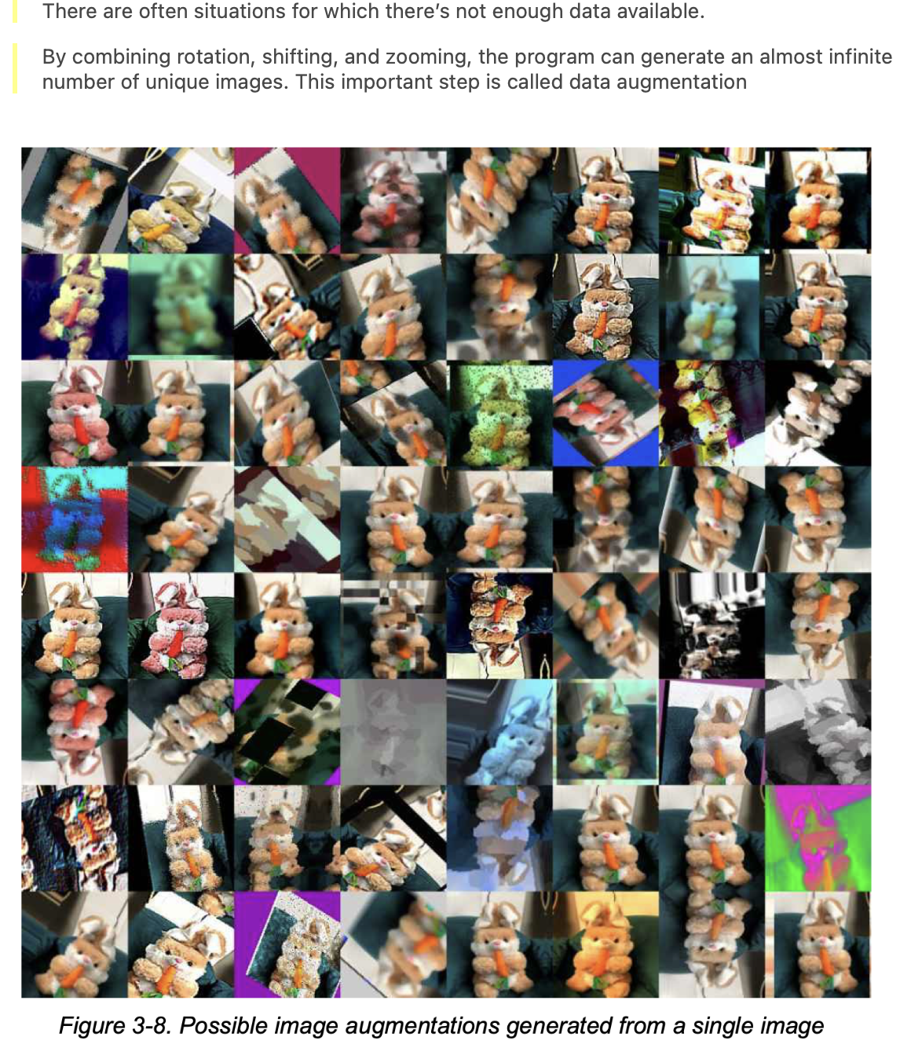

So now you know why you learned all this jibber-jabber. Can you see what all operations we learned today are here ?

1. High and Low pass filters:

Search more on internet about it. 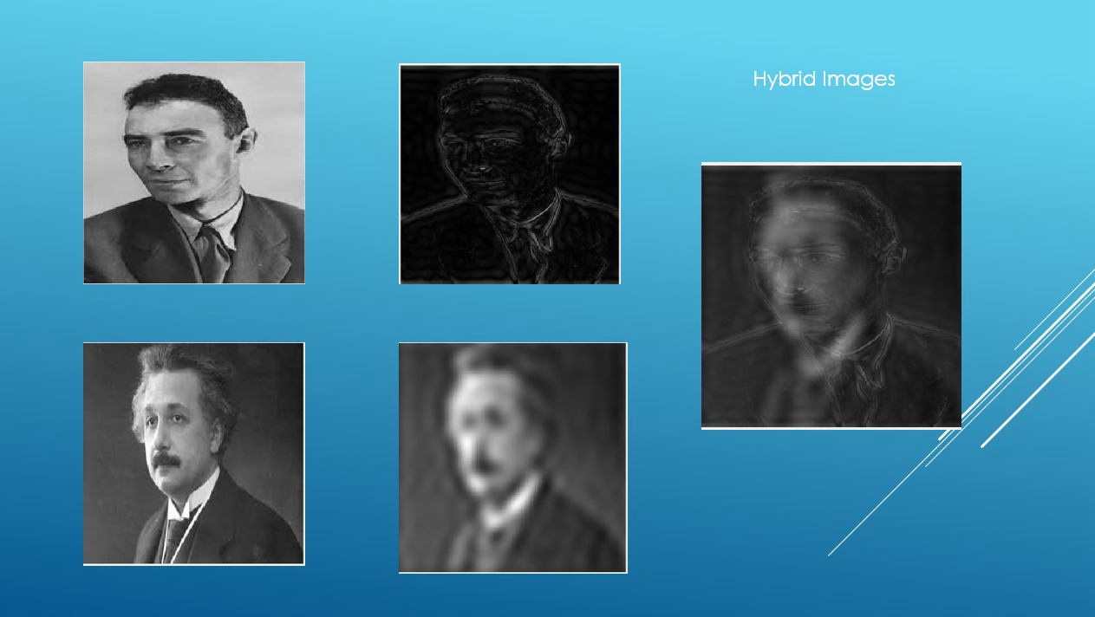

Take Two images of your choice . In first you apply a high pass filter. In other apply a low pass fiilter, and combine them . Print all the five images . You can learn more on how the filter works by the follwing image . where the first row does high filter and the second layer low filter. Find out how .

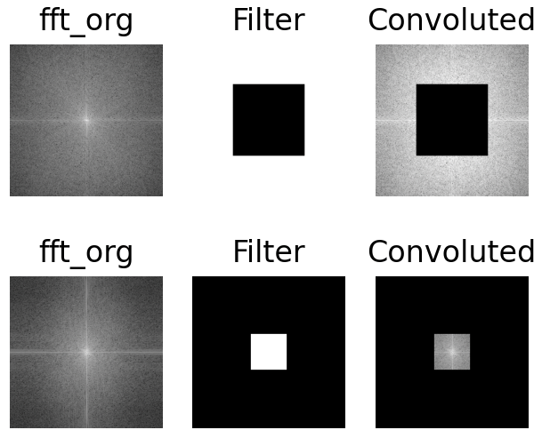In the hybrid image shown, If you squint your eyes , you will see albert einstein , and if you come very close to the screen and see open eyes , you will see oppenheim !!!

Do it yourself :)

1. Have you seen python/ Numpy from the github repo I have sent ? What difficulties did you face (if any !).
2. Then lets test it ! Using only basic Python functions write a program to determine if a given image is the flag of Indonesia or Poland when a user inputs an image of either flag. Upload your code, and in the LaTeX file, explain the logic used in your solution. (libraries allowed: numpy and pillow )

[note the flag of indonesia need not be 

(so simple ).

Keep in mind the other alternative inputs can be

 or 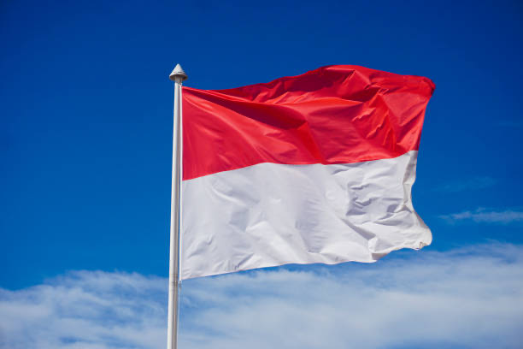 etc.]

Additional Content that you must watch : [Image Processing with OpenCV and Python](https://www.youtube.com/watch?v=kSqxn6zGE0c)

[The Digital Image — An Introduction to Image Processing Basics | by Matt Maulion](https://mattmaulion.medium.com/the-digital-image-an-introduction-to-image-processing-basics-fbdf9fd7f462)

Something cool to know: [The billion dollar race for the perfect display](https://www.youtube.com/watch?v=TyUA1OmXMXA)

**Instructions for assignment submission.:**

create a latex pdf ( when you are first solving , you can first write it on a doc and then ask the chatgpt to convert it into a latex file ). And submit (1-3 are universal)

1. Insights whatever you have learned .

2. Only the Output image (used by (1.) function )

3. Output in your console , where your pycharm is shown. (full screen)

4. Whatever else is asked in the problem.

Note you can directly write your answer. No need to write the problem statement.

Use the latex template : <https://www.overleaf.com/read/zxfpkxztjbvk#1af388>

I just want to see that you have put your effort of searching on the internet. If you find something on the internet , you can directly put the screenshot of that in the latex file, instead of writing it out for me !

The more you have invested your time here , the more it will be easy to revise at the time before intern season .

Submit your code in a github repo and provide a link to me. Learning how to use git is highly encouraged. It will help you ahead.

Sample Video : [Git and GitHub for Beginners - Crash Course](https://www.youtube.com/watch?v=RGOj5yH7evk&t=1900s)

Ask your doubts in the group itself, I would not choose to entertain dm’s. If you know the answer to someone else’s doubt do answer, because Its not a course ! I can ratify as many I want.

Suggestions and ranting box /hub ahead :

<https://forms.gle/WKuU4RphLjFTiKEK7> :)

SUBMIT your assignment here : <https://forms.gle/vXT9u94L4uGvukvn8>

Deadline - 17th december ( 9 PM )